AN INTERACTIVE AND HELPFUL PROGRAM TO HELP FOREIGN LANGUAGE LEARNERS LEARN NEW LANGUAGES THROUGH VIDEOS
Shengyi Wang1, Christopher Muller2

1St. Margaret’s Episcopal School, 31641 La Novia Ave, San Juan Capistrano, CA 92675
2Computer Science Department, California State Polytechnic University, Pomona, CA 91768

ABSTRACT

ForeignLanguagePro is a foreign language learning app targeted at beginner to intermediate level language learners to help them learn a new language while watching videos they enjoy [1]. This app is created in hopes of solving the problem of not having an enjoyable time learning a foreign language without engaging or interesting activities to look at while learning [2]. In the program of the app, AI is heavily used in order to automatically transcribe the videos, tokenize or select certain types of words in the transcript and generate multiple choice questions from the selected words. Firebase is used as an iCloud database for the program. Challenges such as tokenization not selecting the right words and ChatGPT needing a membership to authenticate the user are fixed by understanding how to use these functions correctly [3]. My application works with basically everyone who wants to watch a video while learning a new language. The most important result that I found is that you can make an effective and simple app that can be expanded extensively in terms of the diversity of videos users can choose from while attempting to learn a new language. I think my idea is very helpful to everyone who wants to learn a new language at the moment and also does not want to bore themselves out from constantly doing repetitive practice to learn that language and ultimately make language learning an enjoyable time rather than a tedious one.

KEYWORDS

Foreign Language, Database, Randomizer, Machine Learning

INTRODUCTION

The problem that I am trying to solve with my project is the lack of foreign language learning apps while watching videos or a TV Show. Your teachers in school always tell you to watch movies or listen to songs in a different language to learn and get used to the new language faster. But, what if we can speed up that learning process even more by adding an interactive learning tool to the videos in a foreign language learning app that quizzes users on words in a different language while watching the video. This foreign language app solves the issue of the lack of interactive foreign language learning programs and also speeds up the language learning process by combining pure language learning from an app and also watching TV shows and movies in another language together. The history of this problem came from when I was interested in

David C. Wyld et al. (Eds): AdNLP, CDKP, NCO, SAI, MLT, Signal, SOFT, ICAITA, CMC - 2024
pp. 01-09, 2024. CS & IT - CSCP 2024 DOI: 10.5121/csit.2024.141001

learning Japanese on duolingo and I wanted to be able to be tested on certain phrases and characters while watching japanese shows or while listening to japanese podcasts. This problem is important because many people in the world use duolingo as a means of learning a foreign language but don’t have the option to enjoy shows while learning at the same time while making sure that you are tested on certain vocabulary to make sure users don’t forget. This problem will make the language learning process much quicker and cut the time learning an foreign language normally by half and also increase the enjoyment of the activity.

The three methodologies that I went over in section 5 include the Duolingo language learning app, the video-streaming platform subtitle system as well as the multiple choice fast paced quizzing system from popular multiplayer online quiz games such as Kahoot and Booklet [4]. All of the methodologies try to optimize a certain part of everyday life to be more efficient like watching videos with automated subtitles rather than having no subtitles, taking a quiz online while competing with your friends rather than simply taking a quiz on paper, and learning a new language on an interactive app rather than in the classroom, etc. The shortcomings of the three solutions is simply that there is nothing that combines the ideas of the three to create a language learning app that is able to provide subtitles to videos people enjoy watching while being quizzed in a fast pace on a new language that they may be interested to learn [5]. My project combines these concepts to create what is said above, an efficient and also fun way to learn a new language while watching your favorite videos.

My method of solving this lack of interactive language learning app issue is by creating and coding an interactive foreign language learning app myself. This app allows users to select from a list of interesting videos or popular TV shows to watch in a foreign language while being tested on the vocabulary and phrases spoken during the show on the side. The quiz feature makes sure that the users are actually learning what they are hearing. This app is very effective and efficient in helping another user learn another language all while playing an engaging and interesting show for the users to watch. I think this is very effective because there will be no issues with users getting bored or tired of the app since there are always new choices of TV shows and videos available for users to test out. I think it is a better solution to learning a new language than other language learning apps because it adds a video element into the learning process making it much more enjoyable.

In section 4, I came up with the idea for ForeignLanguage Pro and tested the database, data transcription process and the process of creating multiple choice questions for the app. The significant findings I had was that the app was very effective and simple, and everything worked out in terms of applications. The database was hosted on a cloud server which is backed up and saved constantly preventing any data losses from the videos the user can upload at any time as well as a very neat and organized app frontpage that has each section of the app labeled. (Transcript, Vocabulary, Quiz, etc). The process of transcribing each new video as well as generating questions based off of it also works automatically and efficiently creating a very easy to understand and effective app. The results came out the way they did because my goals were to have an app that is very neat and simplistic and yet also able to hold many videos that users can choose from and even add their own as long as the program is able to automate the transcript, vocabulary and generate questions out of it.

CHALLENGES
In order to build the project, a few challenges have been identified as follows.

Database

A major component in my program is the database of the program where all of the videos and the information regarding the videos are stored for the app. When implementing this component, I sometimes would not have access to the database at all times since we used a cloud database, and their servers are not local meaning that they could shut down anytime. I could have stored all of my data locally as one way to solve the issue, but the cloud servers remained online the majority of the time, so it isn’t a major issue.

The API AI Transcriber

Another major component in my program is the API AI Transcriber that does all the transcribing for the videos in the database to be converted into text form on a transcript [6]. AI is used to transcribe the videos to text. The one problem that I encountered in this component of the program would be some transcription errors when I first attempted to convert a video into text and separate out the verbs in the transcript for the multiple-choice questions for the next component of my program. The program would return names many times in addition to the verbs in the transcript. I solved the issue by simply unselecting all the words that have a space in them because that most likely means that it is a name. Upon doing this, the small issue is resolved.

The API AI Question Generator

The final major component of my program is the API AI Question Generator, this portion of the program is generated by ChatGPT. ChatGPT uses AI to generate multiple choice questions from the verbs that are selected from the transcript in the previous component. An issue we ran into while trying to use ChatGPT was not having the right permissions at first. This is because ChatGPT requires you to pay a small fee when using their AI outside of the open ai chatbot. We solved this by simply paying for the free trial on the ChatGPT official website and the question generation didn’t pose too much of an issue.

SOLUTION

The main structure of my program starts with the user uploading a video to the database from any media streaming service such as YouTube, fox news, etc. Then following that, the video is transcribed in the database into text format. Then we will tokenize the transcript which simply separates the verbs found in the transcript of the video. Afterwards, ChatGPT will generate multiple choice questions based on the verbs selected. Finally, the video is uploaded to the app of the program published on the app store. Users can interact with the app and see the video as well as the multiple-choice questions generated. The three major components in my program that link my program together would be the database, the AI transcriber, and the AI question generator [7].

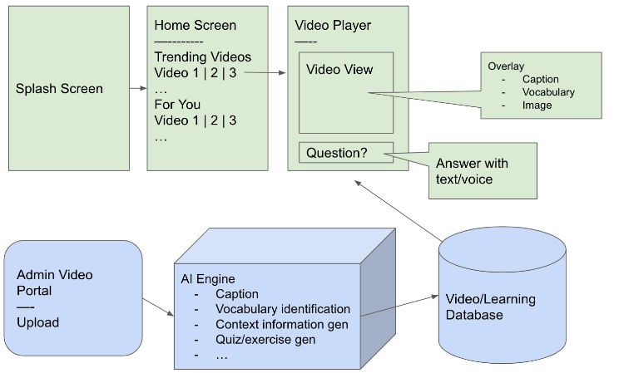

Figure 1. Overview of the solution

One of the components I established in 3.1 was the database of my program. This is the core of the program as it is where the data for the videos are stored at. The database cloud service I used for the program was firebase [8]. The cloud database is a special concept that allows you to save complex and large amounts of data quickly and allows this data to be transferable on the cloud to other devices you potentially might use for the program. Firebase hosts the data on a cloud instance rather than a local instance. This functions with our program well because we use the code to send data to store in the cloud database then send what is in the database through our program code to be uploaded to the program app which can access all of the data.

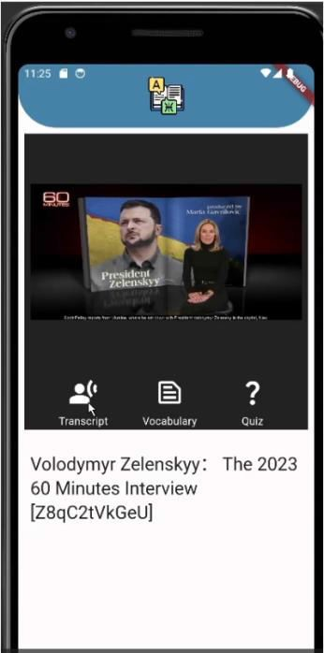

Figure 2. The interview video

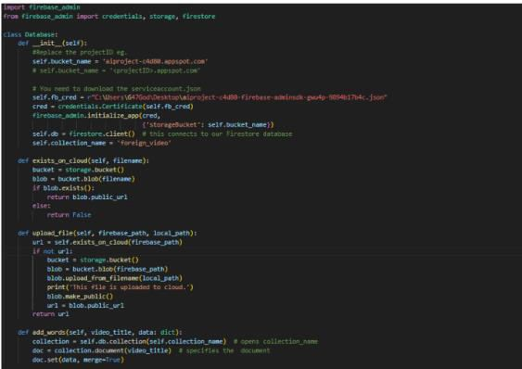

Figure 3. Screenshot of code 1

In the screenshot, we can see the database class which runs when we utilize the database data such as when we are transcribing videos, uploading videos, etc. The methods in the screenshot are different parts of the process for video transcription and the code that makes a connection to the database. A variable example would be the variable self.db functioning as the database connection variable which allows us to interact with our database. Variable self.collection_name is the name of the collection that we are connecting to.

Another one of the components mentioned in 3.1 was the API AI transcriber for my program. This is a crucial part of the program as it is where the script, vocabulary and the verbs for the multiple-choice questions are selected and generated. The special concept for this part of the program would probably be the use of assemblyAI for the transcript generation and verb selection utilized in this part of the program. assemblyAI first converts the uploaded video into the transcript format then proceeds to tokenize all verbs that are found in the transcript. Finally, the verb data is sent to the chatGPT AI multiple choice generator for the multiple-choice questions to be generated in the final part of the program [9].

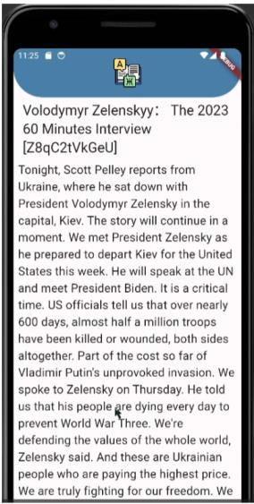

Figure 4. Screenshot of the transcript

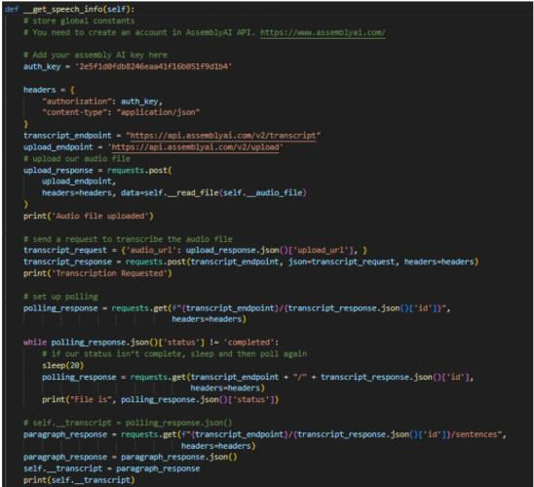

Figure 5. Screenshot of code 2

In this screenshot, we are sending a request to the AI API to transcribe our video. Once it is complete, we save the transcribed data to a local variable made here in the code. The variable Auth_key is the private key that we used to allow the API to recognize us as having permissions to use the AI. This allows us to be able to transcribe videos at any time. Another variable self._transcript is the variable that contains the transcript for our program. The main method
get_speech_info overall contains all of the code used to generate the transcript shown above.

A final component I established in 3.1 was the API AI Multiple Choice question generator, which utilizes the special concept of ChatGPT AI to help generate multiple choice questions based on the selected verbs the program found in the previous component. Artificial intelligence is used in this program as it vastly cuts the time to generate multiple choice questions manually and ChatGPT is able to generate many questions at an extremely fast pace. ChatGPT is a new and highly interactive AI tool that helps people generate, create, fix and update anything and everything that can be found from data on the internet [10]. In terms of my program, it helps with the question generation that cannot be done with many other AI programs out there.

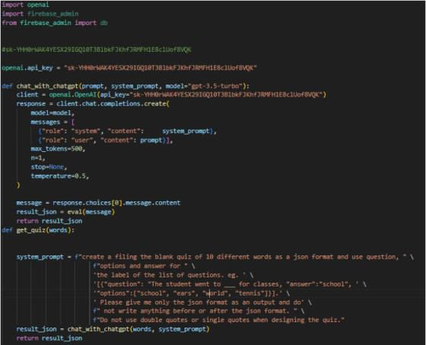

Figure 6. Screenshot of code 3

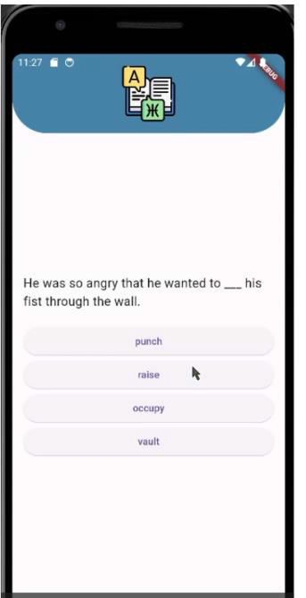

Figure 7. Screenshot of the question

In the code screenshot above, we first connect to the ChatGPT prompt through the client and the API. We create a method called chat_with_chatGPT where we ask them to generate a quiz in the format given using the get_quiz method. These two methods are going to be the core functions for the multiple-choice questions generation. Variable api_key is the variable that holds the authentication key that we were able to receive after paying for the free trial. This key allows us to authenticate ourselves to chatGPT and help generate questions for our program. .system_prompt is another variable that holds the prompt for chatGPT so that it will generate a multiple choice anytime we want.

EXPERIMENT

The problem that inspired me to make Foreign Language Pro is the lack of apps out there that allows people to learn new languages from videos that they enjoy. There are certain language learning apps that include videos but don't give users the freedom to choose the type of genre or language that they want to learn while others such as Duolingo simply doesn’t include a video feature at all. These problems mainly affect people who want to learn the language as they are listening or watching things spoken in the particular language. I think this is a good problem to solve because language learning is extremely important since it is the only real way for people from different countries to even communicate with one another [14]. Without the process of learning a new language, we will struggle to communicate with people and lose out on opportunities to make friends or form bonds with others that speak a different language. In terms of our current time period, countries are often finding themselves in discussions which require translators that speak both languages and learning new languages is crucial in that regard because without communication, arguments and misunderstandings can break out among people. The common saying that was used when I was learning English almost 7 years ago was that listening to English music and watching shows and movies in English would help me learn the language fast and effectively. I found it true that it was engaging to listen to music and watch shows but wasn’t able to remember most of the vocabulary and structure of the sentences that are spoken in those activities. With something like the Foreign Language Pro, you are able to be quizzed on the language while still having the entertainment aspect of the activities at the same time.

My app's idea is to create an app that allows users to upload videos to a database where the video is transcribed to a transcript. The transcript is then tokenized to target certain types of words such as verbs/ adjectives, etc. These selected words are then put into an AI program that automatically generates multiple choice questions that are given to users as they are watching the video, helping them practice using the language as they watch the entertainment they enjoy [15]. The concept behind my application is that users can upload many different types of videos at a fast pace with AI automatically completing the rest of the data including creating the transcript, tokenizing it and finally generating multiple choice questions that are ultimately uploaded to the app. This solution is unique when compared to other solutions due to its effectiveness and simplicity. It simply combines the process of watching your favorite types of videos while helping you learn how to communicate in the new language at the same time and this will save time and makes your entertainment more worth the time you spend on it since you will also simultaneously learn a new language while you enjoy the video as you normally do.

RELATED WORK
One source that I took inspiration from and used before that tackles a similar problem as my program is Duolingo [11]. Duolingo is a language learning app that focuses less on lectures and long paragraphs of teaching but short pages of information then immediately testing the user with different forms of questions such as multiple choice, short response, and piecing together words and sentences from another language. The limitations of Duolingo is that it simply chooses the words you learn from each lesson without the users freedom to learn what they want to really learn about. The user follows the path of the lessons and continues to learn based on the curriculum provided by Duolingo. My project allows users to enjoy their own interest through watching videos and cartoons and during that process learn more about the language that they are listening to by getting quizzed on what they are hearing.

Another scholarly source I took inspiration from is the subtitle system that is present in many video-streaming websites and apps that allow the users to see subtitles in their preferred language regardless of the language that is spoken in the video [12]. However, this system often has flaws due to not every video being subtitled and some videos lacking certain languages. The goal of my app is to slowly expand the number of languages that are offered and use a scanner tool to scan the language spoken in the video and directly quiz users on the questions at hand. I think this app can be a good intermediate step for foreign language learners to practice the language they are learning at the time.

The third scholarly source I took inspiration from would be the fast-paced quizzing system seen in quiz websites such as Kahoot, Blooket, and Quizizz etc [13]. These websites contain many fast-paced quiz questions that are not complicated yet help users practice their understanding in an efficient manner. I found that system to be extremely helpful when it came to designing the questions section of my app. This type of system allows users to be concentrated and also not be stuck reading complicated sentences because they are kept simple. Overall, the quizzing system aligns well with my language learning app targeted at beginner to intermediate level language learners of their desired language.

CONCLUSIONS

Some limitations to my project would be the lack of diversity in the multiple-choice questions that are generated. In the current version of the program, the only multiple-choice questions available would be the ones using verbs to fill in the blank. I feel like the different types of questions that can be asked should be expanded. Some other things that should be fixed or

optimized would be to be able to upload multiple videos and transcript multiple videos at once therefore allowing us to fill up the database with videos that users can enjoy listening to faster. I would implement the new types of multiple-choice questions by creating a new method similar to the old multiple-choice generator but with a different format and tokenize different types of words in the transcript such as adjectives, adverbs, conjunctions, etc. In terms of optimizing the transcription speed and efficiency, we would either have to expand the number of programs running to be able to handle uploading multiple videos at once or use a different AI program that is more efficient in transcribing videos.

Creating ForeignLanguagePro as well as programming for each of the major components was not something easy to get through considering this is the first app that I tried programming. Overall, it was a great learning experience, and I am happy to see the results of my work turned into an app and published to the app store.

REFERENCES

[1] Pikhart, Marcel. "Human-computer interaction in foreign language learning applications: Applied linguistics viewpoint of mobile learning." Procedia Computer Science 184 (2021): 92-98.
[2] Kacetl, Jaroslav, and Blanka Klímová. "Use of smartphone applications in english language learning—A challenge for foreign language education." Education Sciences 9.3 (2019): 179.
[3] Wu, Tianyu, et al. "A brief overview of ChatGPT: The history, status quo and potential future development." IEEE/CAA Journal of AutomaticaSinica 10.5 (2023): 1122-1136.
[4] Bahjet Essa Ahmed, Heba. "Duolingo as a bilingual learning app: A case study." Arab World English Journal (AWEJ) Volume 7 (2016).
[5] Heil, Catherine Regina, et al. "A review of mobile language learning applications: Trends, challenges, and opportunities." The EuroCALL Review 24.2 (2016): 32-50.
[6] Kobylyukh, Leslav, ZorianaRybchak, and Oleh Basystiuk. "Analyzing the Accuracy of Speech-to- Text APIs in Transcribing the Ukrainian Language." COLINS (2). 2023.
[7] Abd Rahim, Tengku Nurulhuda Tengku, et al. "Automated exam question generator using genetic algorithm." 2017 IEEE Conference on e-Learning, e-Management and e-Services (IC3e). IEEE, 2017.
[8] Khawas, Chunnu, and Pritam Shah. "Application of firebase in android app development-a study." International Journal of Computer Applications 179.46 (2018): 49-53.
[9] Wang, Yuntao, et al. "A survey on ChatGPT: AI-generated contents, challenges, and solutions." IEEE Open Journal of the Computer Society (2023).
[10] Venkatesh, Viswanath. "Adoption and use of AI tools: a research agenda grounded in UTAUT." Annals of Operations Research 308.1 (2022): 641-652.
[11] Miró, Juan Daniel Valor, et al. "Efficiency and usability study of innovative computer-aided transcription strategies for video lecture repositories." Speech Communication 74 (2015): 65-75.
[12] Rezigalla, Assad Ali. "AI in medical education: uses of AI in construction type A MCQs." BMC medical education 24.1 (2024): 247.
[13] Emmadi, Sai Spandhana Reddy, and Sirisha Potluri. "Android based instant Messaging application using Firebase." Int. J. Recent Technol. Eng 7.5S2 (2019): 352-355.
[14] Warschauer, Mark, and Deborah Healey. "Computers and language learning: An overview." Language teaching 31.2 (1998): 57-71.
[15] Shortliffe, Edward H., et al. "An artificial intelligence program to advise physicians regarding antimicrobial therapy." Computers and Biomedical Research 6.6 (1973): 544-560.

© 2024 By AIRCC Publishing Corporation. This article is published under the Creative Commons Attribution (CC BY) license

